Librera Search Solution
Enables indexing content from PDFs making it searchable with the possibility to classify them by the Web UI

Contents
Requirements 2
Overview 3
Clean Architecture 4
Scope 5
RQ-01 | Automated Task Service 6
RQ-02 | Indexer 9
RQ-03 | Model Layer 10
RQ-04 | Web API 11
RQ-05 | Front end App 13
RQ-06 | Database 17
Deployment 18
Software life cycle management 19
Annexes 20

Doc. Version | Date | Author | Description
1.0 | 2025-12-17 | https://github.com/kraftcoding | First version of the release

Requirements
The next table shows the requirements for the solution described.
Requirement | Description
RQ-001 | Automated Task Service | Hangfire offers the possibility to manage automated task services to process PDFs
RQ-002 | Indexer | The indexer libraries that contains the logic to process the PDFs
RQ-003 | Model Layer | The model layer with EF core to interact with database
RQ-004 | Web API | The back-end to execute CRUD operations in server
RQ-005 | Front end App | Angular App to offer UI to manage the records and associated records
RQ-006 | Database | The data model, full text search and index services and the logic needed by Stored Procedures

Overview
This document contains the technical details of the Librera Search v1.x solution built with Angular 16, Hangfire Server and .Net 8; enables to index content from PDFs making it searchable with the possibility to classify them by the Web UI. Implements token-based authentication for registered users and policy-based authorization in the endpoints.
The application contains the next functionality:
- Each register has id, title ,authors ,series, ids, published, publisher, languages, tags, formats, path and indexed content
- We can create, retrieve, update, delete records, launch the index service and search PDF content linked to the records
- Includes two pages for finding registers by title or search indexed content
- JWT (JSON Web Token) format used for authentication
- Policy-based authorization in the endpoints
Token-based authentication is a popular approach to securing web applications, providing a stateless and scalable way to verify user identities. In this implementation, we'll explore how to integrate token-based authentication using Angular 16 as the frontend framework and .Net 8 WebAPI as the backend API.
Token-based authentication involves generating a unique token upon successful user authentication, which is then passed with each subsequent request to verify the user's identity. This approach eliminates the need for server-side session storage, making it ideal for modern web applications.
Key Components:
- .Net 8 WebAPI: Handles token generation and validation
- Angular 16: Manages user authentication and includes the token in requests
- JWT (JSON Web Token): The token format used for authentication
- Clean architecture
This implementation provides a secure and efficient way to authenticate users, allowing for seamless interaction between the frontend and backend.
In ASP.NET, policies are used to define requirements that must be met in order to give a user the authorization to access an endpoint.
Within Web API projects you can use policies to guard and protect endpoints from unauthorized users that don't meet the criteria. Instead of writing the authorization logic in the endpoint itself, you can refactor this into a policy that is reusable across multiple endpoints. By extracting the authorization logic from the endpoint, you can make your code more clear and keep your endpoints concise.

Clean Architecture
Clean Architecture is an architecture pattern that is based on four layers: presentation, application, domain, and infrastructure. The presentation layer is responsible for handling user interactions, the application layer is responsible for handling the business logic, the domain layer is responsible for defining the business entities and their relationships, and the infrastructure layer is responsible for handling external concerns such as databases and web services.
Here the solution structure (Visual Studio 2022):
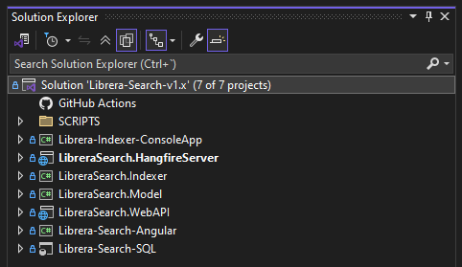
The key principles of Clean Architecture include the independence of the layers, the data flow from the outer layers to the inner layers, and the ability to swap out dependencies without affecting the rest of the system. Clean Architecture emphasizes the separation of concerns to make the codebase easier to maintain, test, and extend.
The project structure of Clean Architecture follows a structured layout that enables code reusability and testability. In the project structure, you would typically have a project for the presentation layer, a project for the application layer, a project for the domain layer, a project for the infrastructure layer, and a project for the tests. Each layer would have its own set of interfaces and implementations, with the application layer acting as the bridge between the other layers.

Scope
This first version of the solutions grants a view of how could be easily implemented in .NET 8 a simple but effective tool to manage book records and make content searchable using open source elements like Hangfire and front-end technologies like Angular.

RQ-01 | Automated Task Service
An easy way to perform background processing in .NET and .NET Core applications. No Windows Service or separate process required. Backed by persistent storage. Open and free for commercial use.
Here the Book Indexer Job definition in the dashboard:
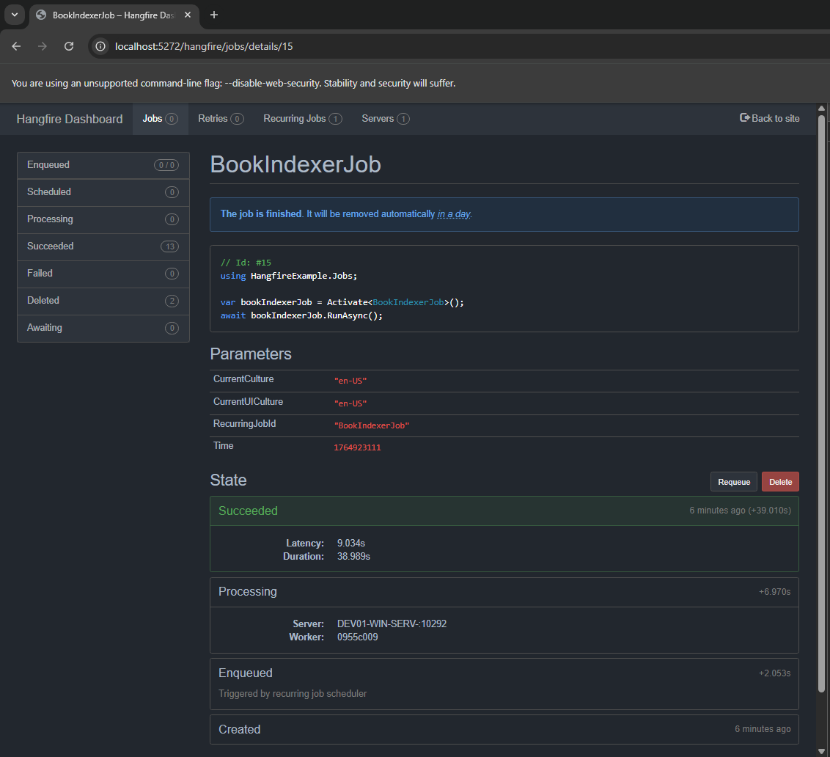
The next image image shows the process graph:
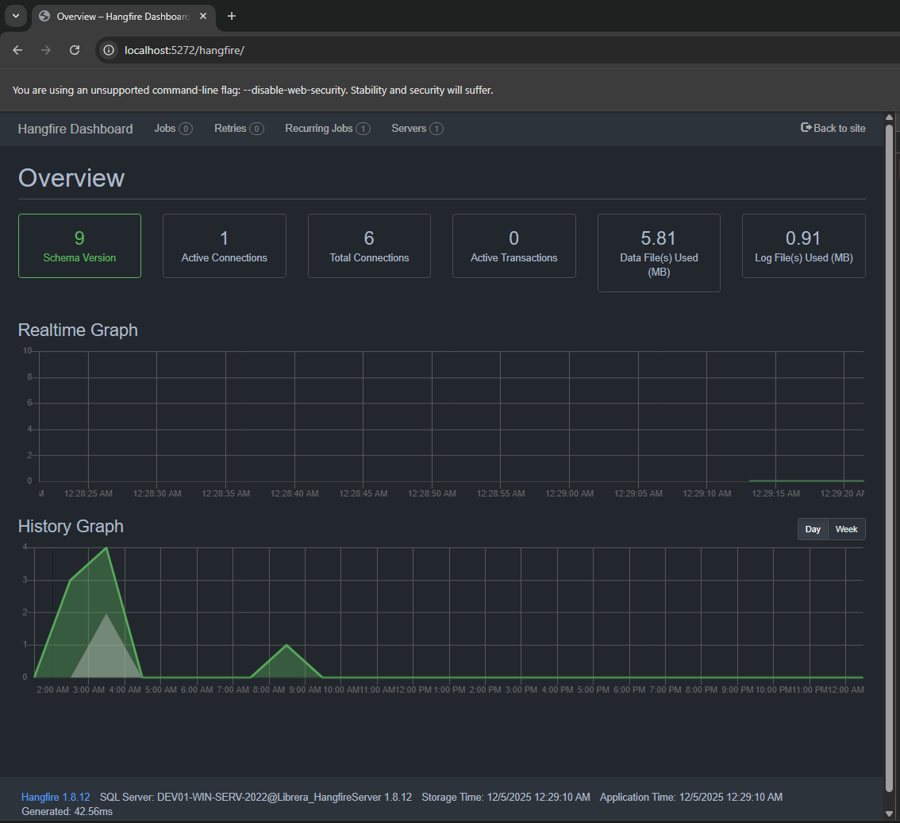
Here the recurring Job:

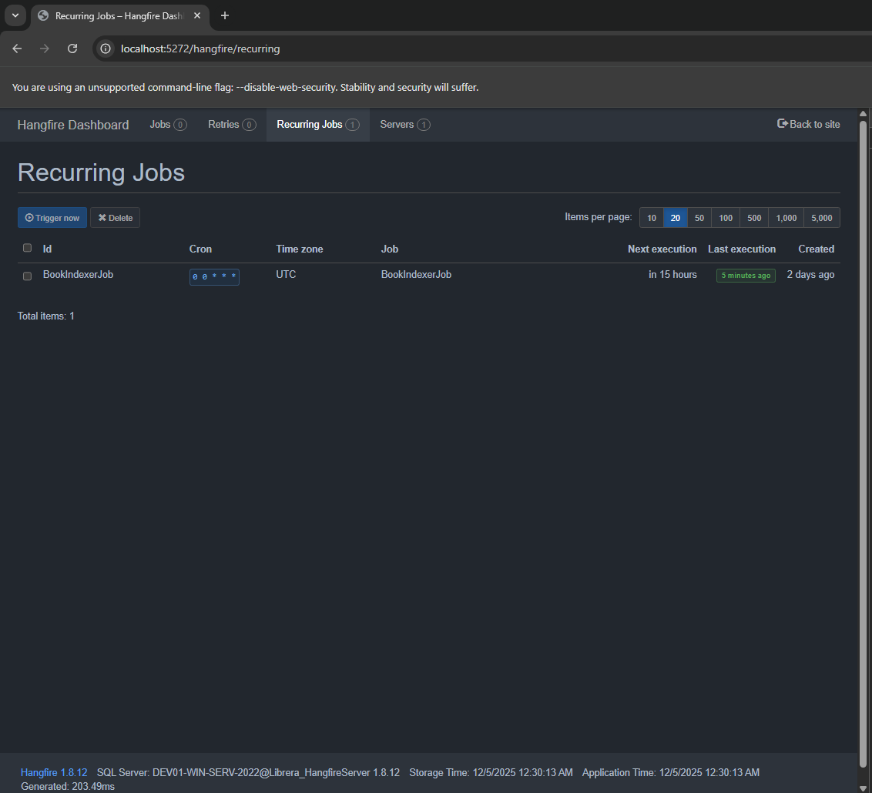
Here the Hangfire service definition for the Job:
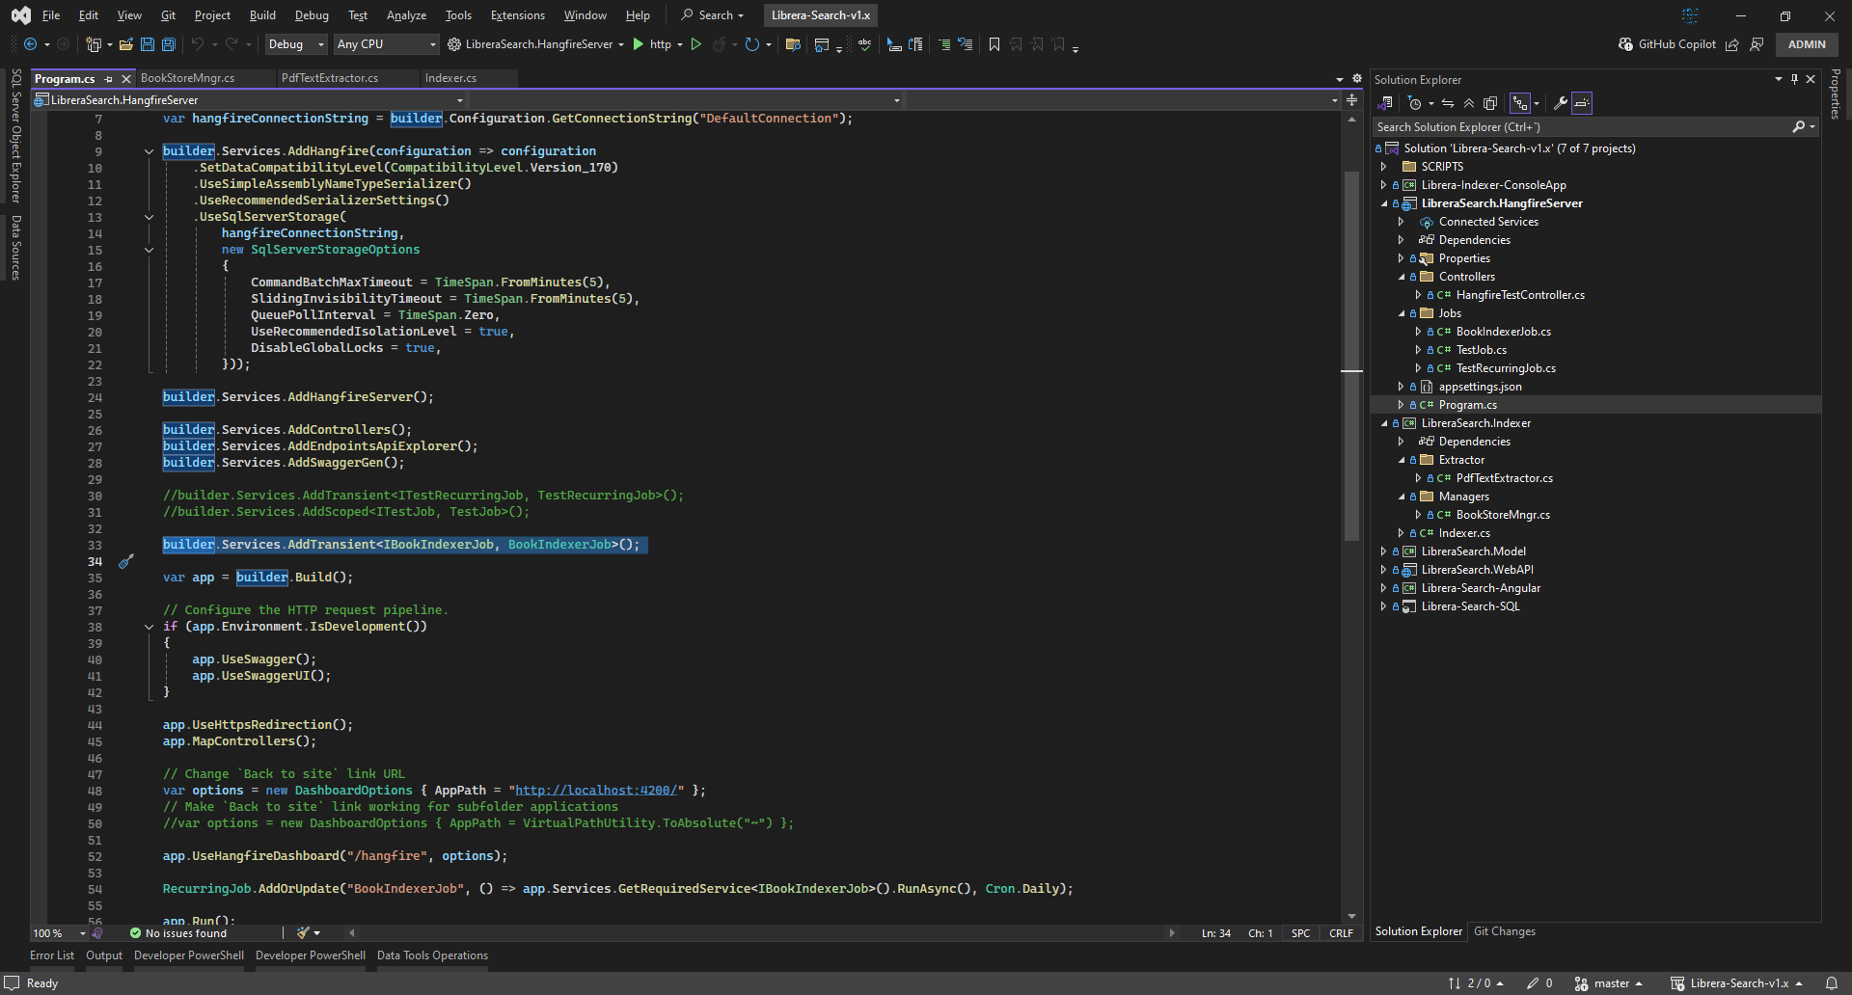

RQ-02 | Indexer
The indexer is implemented by a library type project on which we have the PDF extractor and the c# method that the Hangfire service will call by a recurring job definition.
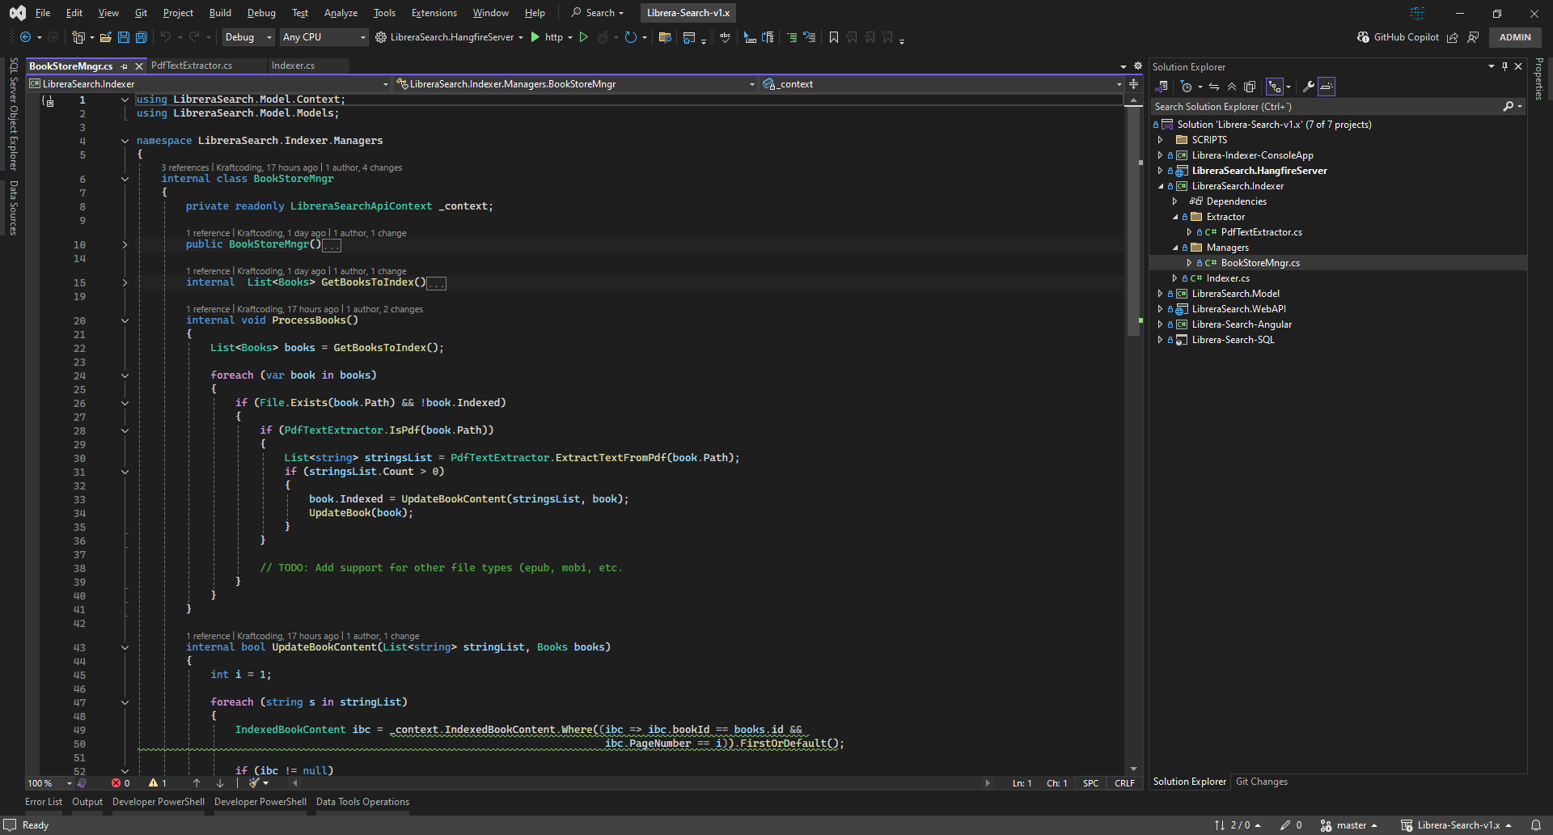
The indexer extraccts content form PDFs and stores it in DB.

RQ-03 | Model Layer
The model layer is managed by EF Core and LinQ is used to launch the queries.

RQ-04 | Web API
The Web API permits to the front-end application to execute CRUD operations my RESTful end-points. Those end-points are securitized by policy-based authorization.
Here some images.
Web API Auth. service setup:
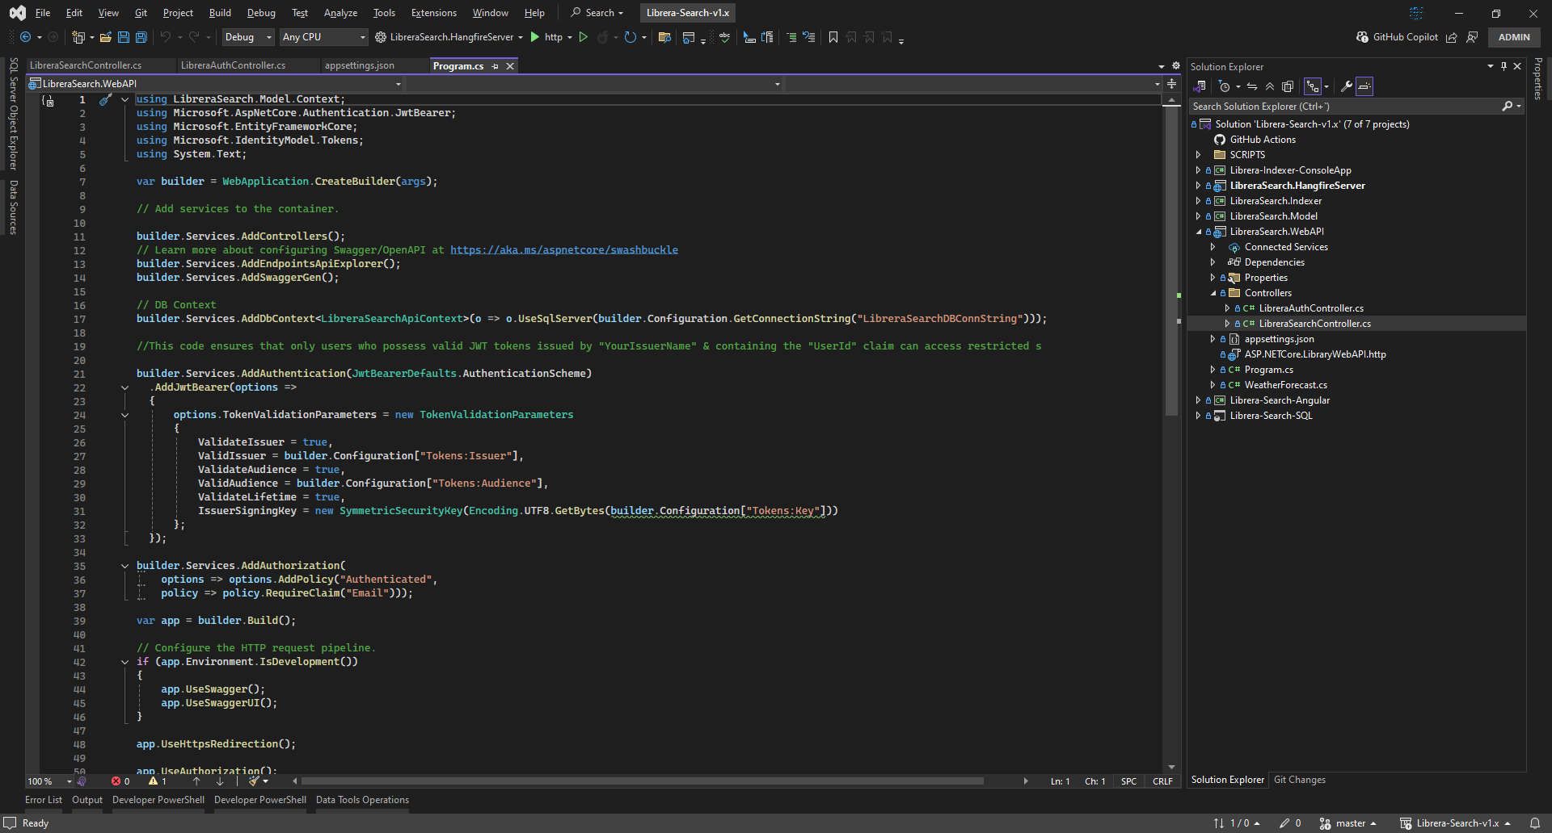
Web API Tokens configuration:
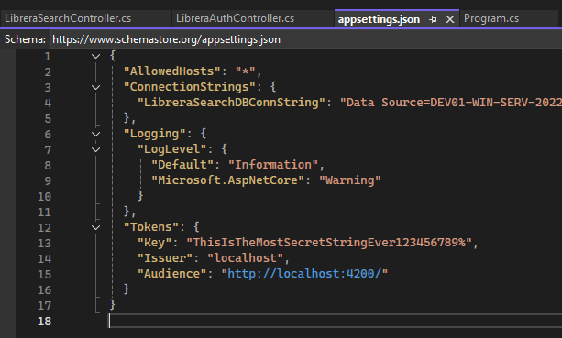
Web API securitized end-points:
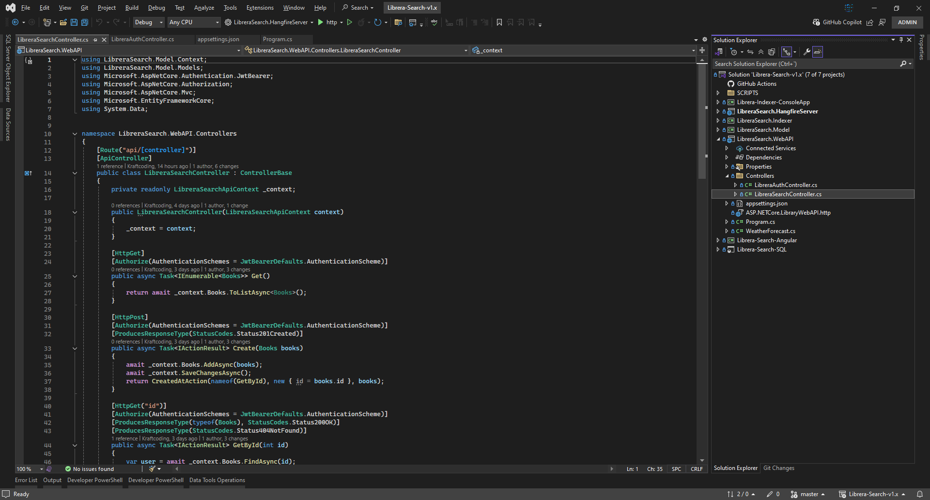

RQ-05 | Front end App
The front end app is built in Angular 16.
Here some images.
Login form:
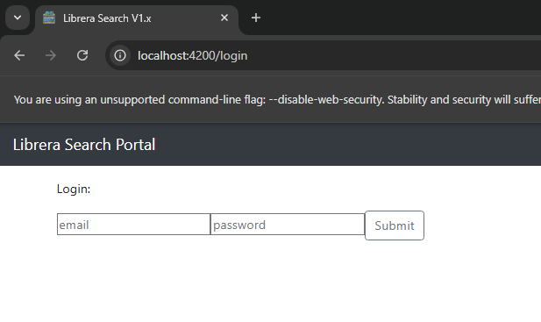
Search by title list and details:
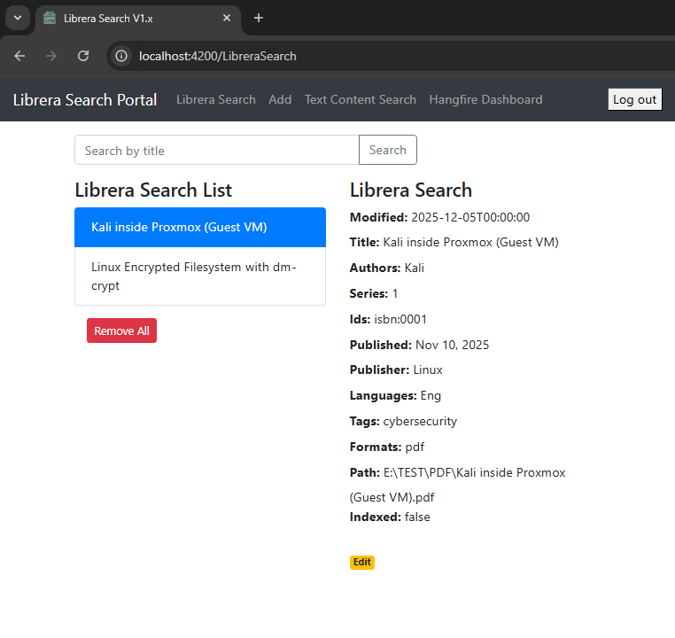
Add form:
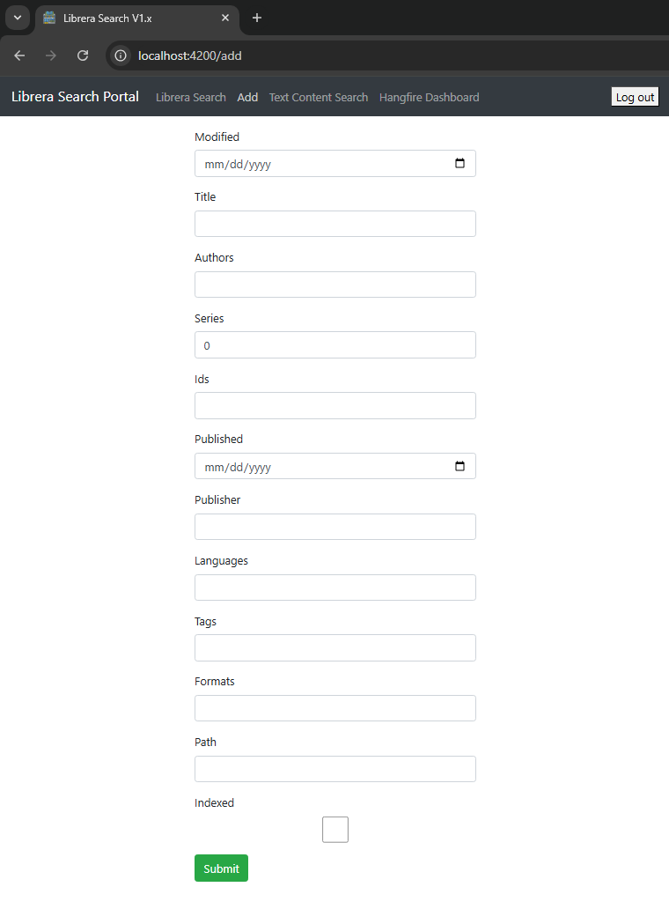
Search by content page details:
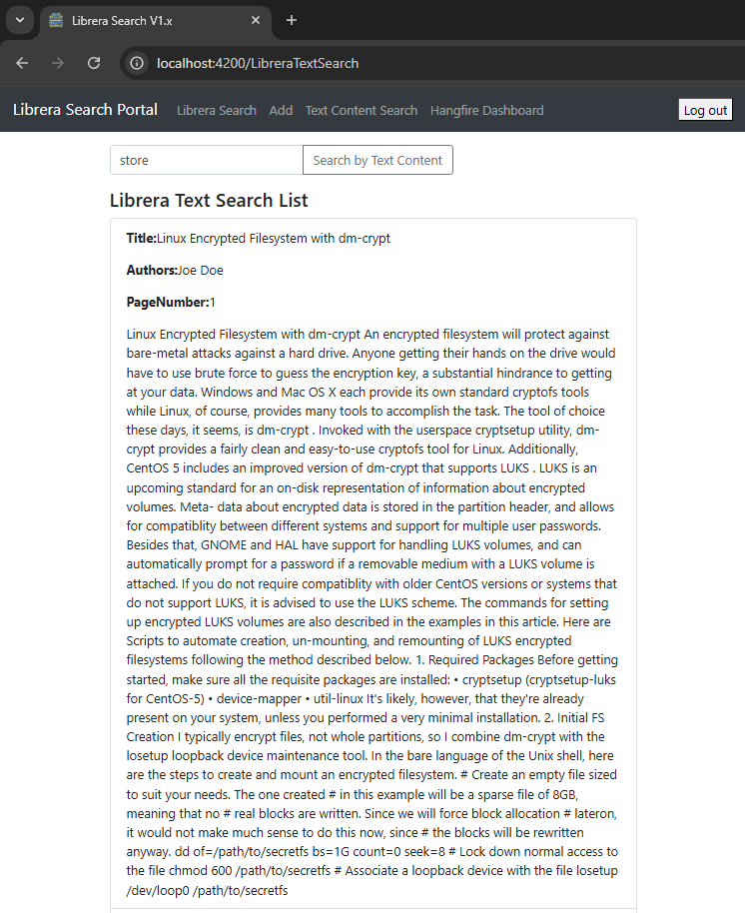

RQ-06 | Database
The database is hosted by M. SQL Server 2022, all the schemas and T-SQL logic is in the project. Full-Text Search feature is needed, as we se in the next image:
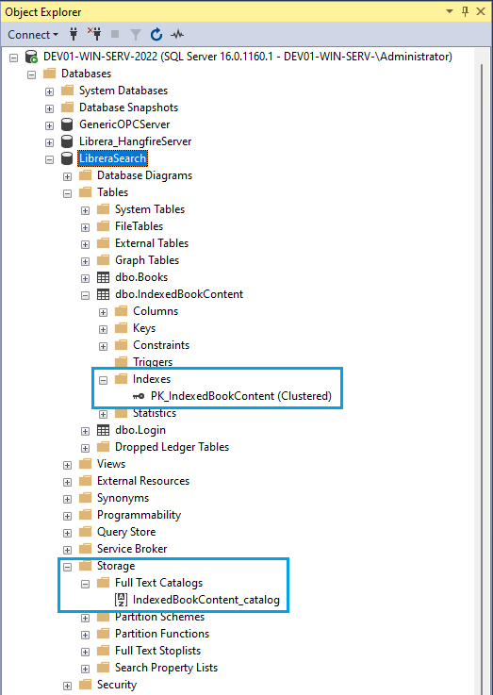

Deployment
To do.

Software life cycle management
To do.

Annexes
A console App is added to test the indexer.
A script is added to launch Chrome avoiding CORS

